**SR UNIVERSITY**

**AI ASSISTED CODING**

**ASSIGNMENT 6**

**NAME :** MOHAMMED MUTAKABIR HUSSAIN

**H.NO :** 2503A51L35

**Assignment Number:6.4**

**TASK 1**

**Task Description #1:**

**•** Start a Python class named Student with attributes name, roll_number, and marks. Prompt GitHub Copilot to complete methods for displaying details and checking if marks are above average.

**Prompt:**

Start a Python class named Student with attributes name, roll number, and marks, Prompt GitHub Copilot to complete methods for displaying details and checking if marks are above average.

**

**Output:**

**Observation:**

AI suggested methods to display student details and to check if the student passed or failed using if-else conditions.  
I observed that using AI made the coding work faster and easier.

**TASK 2**

**Task Description #2:**

**•** Write the first two lines of a for loop to iterate through a list of numbers. Use a comment prompt to let Copilot suggest how to calculate and print the square of even numbers only.

**Prompt :** how to calculate and print the square of even numbers only.

**Code :**

**Output:**

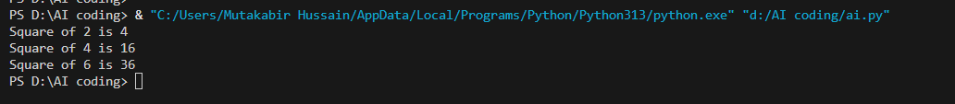

**Observation:**

I observed that AI suggestions helped to quickly complete the loop and add the correct condition.

And completed how to calculate and print the square of even numbers only

**TASK 3**

**Task Description #3:**

**•** Create a class called BankAccount with attributes account_holder and balance. Use Copilot to complete methods for deposit(), withdraw(), and check for insufficient balance.

**Prompt:** Create a class called BankAccount with attributes account_holder and balance. Use Copilot to complete methods for deposit(), withdraw(), and check for insufficient balance

**Code:**

**

**Observation:**

AI helped me complete the methods for depositing and withdrawing money.  
The withdraw method uses an if condition to check for insufficient balance, which prevents overdrawing.  
I observed that AI suggestions made it easier to write correct methods using simple conditions.

**TASK 4**

**Task Description #4:**

**•** Define a list of student dictionaries with keys name and score. Ask Copilot to write a while loop to print the names of students who scored more than 75.

**Prompt**: write a while loop to print the names of students who scored more than 75

**Code:**

**Output:** 

**Obseravtion:** we created a list of students where each student was stored as a dictionary with a name and score.

AI helped me write a while loop to go through the list.

With the help of the AI program it printed only the students who scored more than 75

**TASK 5**

**Task Description #5:**

• Begin writing a class ShoppingCart with an empty items list. Prompt Copilot to generate methods to add_item, remove_item, and use a loop to calculate the total bill using conditional discounts.

**Prompt:** generate methods to add_item, remove_item, and use a loop to calculate the total bill using conditional discounts

**Observation:**

We created a Shopping Cart class with an empty items list  
AI helped to generate methods to add and remove items from the cart  
I observed that AI suggestions made it easier to complete the task